Assignment no.4
Generalized Linked Lists (GLLs)
Course Name : Data Structures-I
Course Code : CS2301
Div : SEDA-B
Student Name : Yashraj Dinesh Hande
Roll Number : 18
Date of Submission : 23/11/2025
Advanced Linked Lists and Applications
A linked list is a dynamic data structure that stores data elements (called nodes) connected via pointers.
As we move to advanced applications, linked lists can be extended beyond simple linear lists to represent hierarchical, bidirectional, and complex structures like Generalized Linked Lists (GLLs), Doubly Linked Lists (DLLs), and nested or structured data.
These forms are extremely useful for implementing mathematical expressions, sets, and memory-efficient algorithms.

🔹 1. Generalized Linked List (GLL)
A Generalized Linked List is an advanced type of linked list in which each node may contain either:
- Atomic data (simple element), or
- A pointer to another list (nested list).
This allows hierarchical structures like:
S = {p, q, {r, s, t, {}, {u, v}, w, x, {y, z}, a1, b1}}
Such a structure cannot be stored in a simple linear list, so a GLL is used.
Each node of a GLL contains:
- A flag indicating whether it holds an atom or a sublist.
- A data field or a pointer to a sublist.
- A next pointer to the next element.
Applications:
Used in expression trees, symbol tables, and recursive data representations like JSON or XML parsing.
🔹 2. Polynomial Representation and Addition using Linked List
A polynomial can be represented as:
$$P(x)=5x^{3}+2x^{2}+4x+7$$
Polynomial Addition:
- Traverse both lists simultaneously.
- If powers are equal → add coefficients.
- If powers differ → copy the term with higher power.
Result is a new linked list representing the sum.
🔹 3. Bubble Sort using Doubly Linked List
A Doubly Linked List (DLL) allows traversal in both directions using next and prev pointers.
When Bubble Sort is implemented on a DLL:
- Adjacent nodes are compared and swapped based on their data.
- It is easier to swap entire nodes instead of just data due to bidirectional links.
Advantages:
- Efficient traversal and swapping.
- No need for array indexing.
🔹 4. Insertion and Deletion in Doubly Linked List
In a DLL:
- Each node contains prev, data, and next.
- Insertion and deletion can be performed:
  - At beginning
  - At end
  - After a specific node
- These operations require careful pointer adjustments but allow flexible memory manipulation.
Applications:
Used in undo-redo operations, music/video playlists, and browser history management.
🔹 5. Front–Back Split Operation on Linked List
This operation divides a single linked list into two sublists:
- Front list: Contains the first half of elements.
- Back list: Contains the remaining half.
If the number of nodes is odd, the extra node goes to the front list.
Technique:
- Use fast and slow pointers:
  - Move fast by two nodes, slow by one.
  - When fast reaches the end, slow is at the midpoint.
- Split the list at slow.
Use Case:
Commonly used in Merge Sort and Load Balancing algorithms on linked data.

Problem 1 : Write a C++ program to implement a Set using a Generalized Linked List (GLL). For example: Let S = { p, q, {r, s, t, {}, {u, v}, w, x, {y, z}, a1, b1} } Store this structure using a Generalized Linked List and display the elements in correct set notation format.

Code :
#include <iostream>
#include <string>
using namespace std;

class GNode {
public:
int flag; // 0 = atom, 1 = sublist
string data;
GNode* next;
GNode* down;

GNode() {
flag = 0;
next = NULL;
down = NULL;
}
};

class GLL {
public:
GNode* create() {
GNode *head = NULL, *last = NULL;
string token;

while (true) {
cin >> token;
if (token == ")") // end current list
break;

GNode* node = new GNode();
if (token == "(") {
node->flag = 1;
node->down = create(); // recursively create sublist
} else {
node->flag = 0;
node->data = token;
}

if (head == NULL)
head = node;
else
last->next = node;
last = node;
}

return head;
}

void display(GNode* node) {
cout << "{";
while (node != NULL) {
if (node->flag == 0)
cout << node->data;
else
display(node->down);

if (node->next != NULL)
cout << ", ";
node = node->next;
}
cout << "}";
}
};

int main() {
cout << "===========================================\n";
cout << " SET IMPLEMENTATION USING GLL STRUCTURE\n";
cout << "===========================================\n";
cout << "Enter elements (use '(' to start sublist and ')' to end):\n";

GLL obj;
cout << "Example Input: p q ( r s t ( ) ( u v ) w x ( y z ) a1 b1 ) )\n\n";

GNode* head = obj.create();

cout << "\nGeneralized Linked List Representation:\n";
obj.display(head);
cout << endl;
return 0;
}

Output :
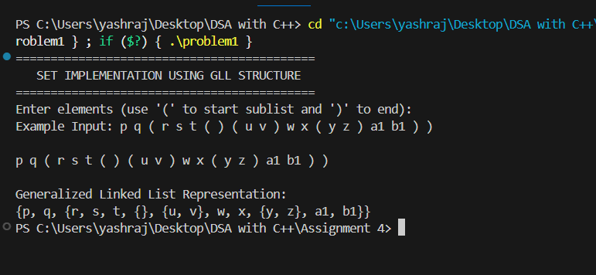

Problem 2 : WAP to perform addition o f two polynomials using singly linked list.
Code:
#include <iostream>
using namespace std;

class Node {
public:
int coeff; // Coefficient
int power; // Power of x
Node* next;

Node(int c, int p) {
coeff = c;
power = p;
next = NULL;
}
};

class Polynomial {
private:
Node* head;

public:
Polynomial() { head = NULL; }

// Function to insert term in decreasing order of power
void insertTerm(int c, int p) {
Node* newNode = new Node(c, p);

if (head == NULL || head->power < p) {
newNode->next = head;
head = newNode;
} else {
Node* temp = head;
while (temp->next != NULL && temp->next->power >= p)
temp = temp->next;

if (temp->power == p) {
temp->coeff += c; // Combine like terms
} else {
newNode->next = temp->next;
temp->next = newNode;
}
}
}

// Function to display polynomial
void display() {
Node* temp = head;
if (!temp) {
cout << "0";
return;
}

while (temp != NULL) {
cout << temp->coeff << "x^" << temp->power;
if (temp->next != NULL && temp->next->coeff >= 0)
cout << " + ";
temp = temp->next;
}
cout << endl;
}

// Function to add two polynomials
Polynomial add(Polynomial P2) {
Polynomial result;
Node *p1 = head, *p2 = P2.head;

while (p1 != NULL && p2 != NULL) {
if (p1->power == p2->power) {
result.insertTerm(p1->coeff + p2->coeff, p1->power);
p1 = p1->next;
p2 = p2->next;
} else if (p1->power > p2->power) {
result.insertTerm(p1->coeff, p1->power);
p1 = p1->next;
} else {
result.insertTerm(p2->coeff, p2->power);
p2 = p2->next;
}
}

while (p1 != NULL) {
result.insertTerm(p1->coeff, p1->power);
p1 = p1->next;
}

while (p2 != NULL) {
result.insertTerm(p2->coeff, p2->power);
p2 = p2->next;
}

return result;
}
};

int main() {
Polynomial P1, P2, P3;
int n, coeff, power;

cout << "=========================================\n";
cout << " POLYNOMIAL ADDITION USING LINKED LIST\n";
cout << "=========================================\n";

cout << "\nEnter number of terms for first polynomial: ";
cin >> n;
for (int i = 0; i < n; i++) {
cout << "Enter coefficient and power: ";
cin >> coeff >> power;
P1.insertTerm(coeff, power);
}

cout << "\nEnter number of terms for second polynomial: ";
cin >> n;
for (int i = 0; i < n; i++) {
cout << "Enter coefficient and power: ";
cin >> coeff >> power;
P2.insertTerm(coeff, power);
}

cout << "\nFirst Polynomial: ";
P1.display();

cout << "Second Polynomial: ";
P2.display();

P3 = P1.add(P2);

cout << "\nResultant Polynomial (P1 + P2): ";
P3.display();

return 0;
}

OUTPUT :
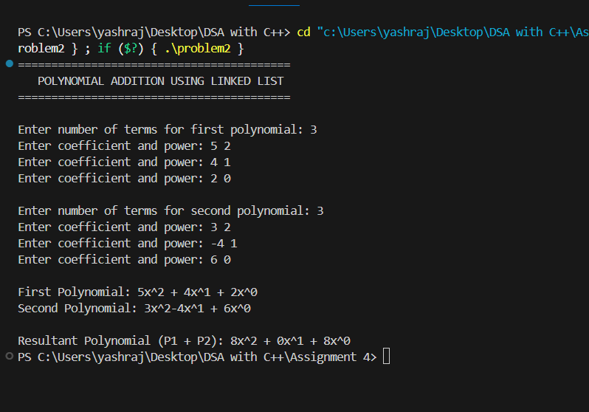

Problem 3 : Implement Bubble sort using Doubly Linked List
Code :
#include <iostream>
using namespace std;

// Node structure for doubly linked list
class Node {
public:
int data;
Node* prev;
Node* next;

Node(int value) {
data = value;
prev = next = NULL;
}
};

// Class for doubly linked list operations
class DoublyLinkedList {
private:
Node* head;
Node* tail;

public:
DoublyLinkedList() {
head = tail = NULL;
}

// Insert node at end
void insert(int value) {
Node* newNode = new Node(value);
if (head == NULL) {
head = tail = newNode;
} else {
tail->next = newNode;
newNode->prev = tail;
tail = newNode;
}
}

// Display list
void display() {
Node* temp = head;
while (temp != NULL) {
cout << temp->data;
if (temp->next != NULL)
cout << " <-> ";
temp = temp->next;
}
cout << endl;
}
// Bubble sort algorithm on doubly linked list
void bubbleSort() {
if (head == NULL)
return;
bool swapped;
Node* ptr1;
Node* lptr = NULL;
do {
swapped = false;
ptr1 = head;
while (ptr1->next != lptr) {
if (ptr1->data > ptr1->next->data) {
// Swap the data values (you could also swap nodes)
int temp = ptr1->data;
ptr1->data = ptr1->next->data;
ptr1->next->data = temp;
swapped = true;
}
ptr1 = ptr1->next;
}
lptr = ptr1;
} while (swapped);
}
};

// ================= MAIN FUNCTION =================
int main() {
DoublyLinkedList dll;
int n, value;
cout << "=========================================\n";
cout << " BUBBLE SORT USING DOUBLY LINKED LIST\n";
cout << "=========================================\n";
cout << "Enter number of elements: ";
cin >> n;
for (int i = 0; i < n; i++) {
cout << "Enter element " << i + 1 << ": ";
cin >> value;
dll.insert(value);
}

cout << "\nOriginal List:\n";
dll.display();

dll.bubbleSort();
cout << "\nSorted List (Ascending Order):\n";
dll.display();
return 0;
}
OUTPUT:
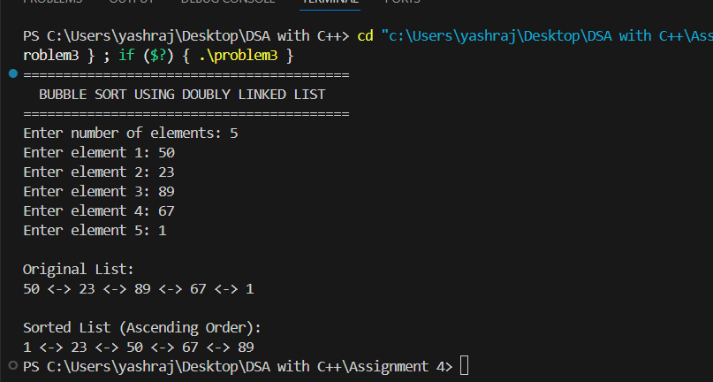

Problem 4 :
WAP to create a doubly linked list and perform following operations on it.A) Insert (all cases) 2. Delete (all cases).
CODE :
#include <iostream>
using namespace std;

class Node {
public:
int data;
Node* prev;
Node* next;

Node(int value) {
data = value;
prev = next = NULL;
}
};

class DoublyLinkedList {
private:
Node* head;

public:
DoublyLinkedList() { head = NULL; }

// Display the list
void display() {
if (head == NULL) {
cout << "List is empty.\n";
return;
}
Node* temp = head;
cout << "NULL <-> ";
while (temp != NULL) {
cout << temp->data << " <-> ";
temp = temp->next;
}
cout << "NULL\n";
}

// Insert at beginning
void insertAtBeginning(int value) {
Node* newNode = new Node(value);
if (head != NULL) {
newNode->next = head;
head->prev = newNode;
}
head = newNode;
cout << "Inserted " << value << " at beginning.\n";
}

// Insert at end
void insertAtEnd(int value) {
Node* newNode = new Node(value);
if (head == NULL) {
head = newNode;
cout << "Inserted " << value << " as first element.\n";
return;
}

Node* temp = head;
while (temp->next != NULL)
temp = temp->next;

temp->next = newNode;
newNode->prev = temp;
cout << "Inserted " << value << " at end.\n";
}

// Insert after specific node
void insertAfter(int key, int value) {
Node* temp = head;
while (temp != NULL && temp->data != key)
temp = temp->next;

if (temp == NULL) {
cout << "Node with data " << key << " not found.\n";
return;
}

Node* newNode = new Node(value);
newNode->next = temp->next;
newNode->prev = temp;

if (temp->next != NULL)
temp->next->prev = newNode;

temp->next = newNode;

cout << "Inserted " << value << " after " << key << ".\n";
}

// Delete from beginning
void deleteFromBeginning() {
if (head == NULL) {
cout << "List is empty.\n";
return;
}

Node* temp = head;
head = head->next;
if (head != NULL)
head->prev = NULL;

cout << "Deleted " << temp->data << " from beginning.\n";
delete temp;
}

// Delete from end
void deleteFromEnd() {
if (head == NULL) {
cout << "List is empty.\n";
return;
}

Node* temp = head;
if (temp->next == NULL) {
cout << "Deleted " << temp->data << " from end.\n";
delete temp;
head = NULL;
return;
}

while (temp->next != NULL)
temp = temp->next;

cout << "Deleted " << temp->data << " from end.\n";
temp->prev->next = NULL;
delete temp;
}

// Delete specific node
void deleteSpecific(int key) {
if (head == NULL) {
cout << "List is empty.\n";
return;
}

Node* temp = head;

while (temp != NULL && temp->data != key)
temp = temp->next;

if (temp == NULL) {
cout << "Node with data " << key << " not found.\n";
return;
}

if (temp->prev != NULL)
temp->prev->next = temp->next;
else
head = temp->next;

if (temp->next != NULL)
temp->next->prev = temp->prev;

cout << "Deleted node with data " << key << ".\n";
delete temp;
}
};

// ================= MAIN FUNCTION =================
int main() {
DoublyLinkedList dll;
int choice, value, key;

cout << "===============================================\n";
cout << " DOUBLY LINKED LIST IMPLEMENTATION (INSERT/DELETE)\n";
cout << "===============================================\n";

do {
cout << "\n------ MENU ------\n";
cout << "1. Display List\n";
cout << "2. Insert at Beginning\n";
cout << "3. Insert at End\n";
cout << "4. Insert After a Node\n";
cout << "5. Delete from Beginning\n";
cout << "6. Delete from End\n";
cout << "7. Delete Specific Node\n";
cout << "8. Exit\n";
cout << "Enter your choice: ";
cin >> choice;

switch (choice) {
case 1:
dll.display();
break;
case 2:
cout << "Enter value to insert: ";
cin >> value;
dll.insertAtBeginning(value);
break;
case 3:
cout << "Enter value to insert: ";
cin >> value;
dll.insertAtEnd(value);
break;
case 4:
cout << "Enter node value after which to insert: ";
cin >> key;
cout << "Enter new value to insert: ";
cin >> value;
dll.insertAfter(key, value);
break;
case 5:
dll.deleteFromBeginning();
break;
case 6:
dll.deleteFromEnd();
break;
case 7:
cout << "Enter value of node to delete: ";
cin >> key;
dll.deleteSpecific(key);
break;
case 8:
cout << "Exiting program...\n";
break;
default:
cout << "Invalid choice! Try again.\n";
}
} while (choice != 8);

return 0;
}

OUTPUT :
PS C:\Users\yashraj\Desktop\DSA with C++> cd "c:\Users\yashraj\Desktop\DSA with C++\Assignment 4\" ; if ($?) { g++ problem4.cpp -o problem4 } ; if ($?) { .\problem4 }
===============================================
DOUBLY LINKED LIST IMPLEMENTATION (INSERT/DELETE)
===============================================
------ MENU ------
1. Display List
2. Insert at Beginning
3. Insert at End
4. Insert After a Node
5. Delete from Beginning
6. Delete from End
7. Delete Specific Node
8. Exit
Enter your choice: 2
Enter value to insert: 10
Inserted 10 at beginning.

------ MENU ------
1. Display List
2. Insert at Beginning
3. Insert at End
4. Insert After a Node
5. Delete from Beginning
6. Delete from End
7. Delete Specific Node
8. Exit
Enter your choice: 3
Enter value to insert: 20
Inserted 20 at end.

------ MENU ------
1. Display List
2. Insert at Beginning
3. Insert at End
4. Insert After a Node
5. Delete from Beginning
6. Delete from End
7. Delete Specific Node
8. Exit
Enter your choice: 4
Enter node value after which to insert: 10
Enter new value to insert: 15
Inserted 15 after 10.

------ MENU ------
1. Display List
2. Insert at Beginning
3. Insert at End
4. Insert After a Node
5. Delete from Beginning
6. Delete from End
7. Delete Specific Node
8. Exit
Enter your choice: 1
NULL <-> 10 <-> 15 <-> 20 <-> NULL

------ MENU ------
1. Display List
2. Insert at Beginning
3. Insert at End
4. Insert After a Node
5. Delete from Beginning
6. Delete from End
7. Delete Specific Node
8. Exit
Enter your choice: 5
Deleted 10 from beginning.

------ MENU ------
1. Display List
2. Insert at Beginning
3. Insert at End
4. Insert After a Node
5. Delete from Beginning
6. Delete from End
7. Delete Specific Node
8. Exit
Enter your choice: 6
Deleted 20 from end.

------ MENU ------
1. Display List
2. Insert at Beginning
3. Insert at End
4. Insert After a Node
5. Delete from Beginning
6. Delete from End
7. Delete Specific Node
8. Exit
Enter your choice: 7
Enter value of node to delete: 15
Deleted node with data 15.

------ MENU ------
1. Display List
2. Insert at Beginning
3. Insert at End
4. Insert After a Node
5. Delete from Beginning
6. Delete from End
7. Delete Specific Node
8. Exit
Enter your choice: 1
List is empty.

------ MENU ------
1. Display List
2. Insert at Beginning
3. Insert at End
4. Insert After a Node
5. Delete from Beginning
6. Delete from End
7. Delete Specific Node
8. Exit
Enter your choice: 8
Exiting program...
PS C:\Users\yashraj\Desktop\DSA with C++\Assignment 4>
Problem 5 : Given a list, split it into two sublists — one for the front half, and one for the back half. If the number of elements is odd, the extra element should go in the front list. So FrontBackSplit() on the list {2, 3, 5, 7, 11} should yield the two lists {2, 3, 5} and {7, 11}. Getting this right for all the cases is harder than it looks. You should check your solution against a few cases (length = 2, length = 3, length=4) to make sure that the list gets split correctly near the shortlist boundary conditions. If it works right for length=4, it probably works right for length=1000. You will probably need special case code to deal with the (length <2) cases.
CODE :
#include <iostream>
using namespace std;

class Node {
public:
int data;
Node* next;

Node(int val) {
data = val;
next = NULL;
}
};

class LinkedList {
private:
Node* head;

public:
LinkedList() {
head = NULL;
}

// Insert node at the end
void insert(int val) {
Node* newNode = new Node(val);
if (head == NULL) {
head = newNode;
} else {
Node* temp = head;
while (temp->next != NULL)
temp = temp->next;
temp->next = newNode;
}
}

// Display list
void display(Node* node) {
if (node == NULL) {
cout << "Empty list\n";
return;
}
while (node != NULL) {
cout << node->data;
if (node->next != NULL)
cout << " -> ";
node = node->next;
}
cout << endl;
}

Node* getHead() { return head; }

// Function to split the list into front and back halves
void frontBackSplit(Node* source, Node** frontRef, Node** backRef) {
if (source == NULL || source->next == NULL) {
*frontRef = source;
*backRef = NULL;
return;
}

Node* slow = source;
Node* fast = source->next;

// Move 'fast' two nodes and 'slow' one node at a time
while (fast != NULL) {
fast = fast->next;
if (fast != NULL) {
slow = slow->next;
fast = fast->next;
}
}

// Split the list
*frontRef = source;
*backRef = slow->next;
slow->next = NULL;
}
};

// ================= MAIN FUNCTION =================
int main() {
LinkedList list;
int n, val;

cout << "=====================================\n";
cout << " FRONT–BACK SPLIT OF LINKED LIST\n";
cout << "=====================================\n";

cout << "Enter number of elements: ";
cin >> n;

for (int i = 0; i < n; i++) {
cout << "Enter element " << i + 1 << ": ";
cin >> val;
list.insert(val);
}

cout << "\nOriginal List: ";
list.display(list.getHead());

Node* front = NULL;
Node* back = NULL;

list.frontBackSplit(list.getHead(), &front, &back);

cout << "\nFront Half: ";
list.display(front);

cout << "Back Half: ";
list.display(back);

return 0;
}

OUTPUT :
